West Hull Ladies
RRC

July Newsletter
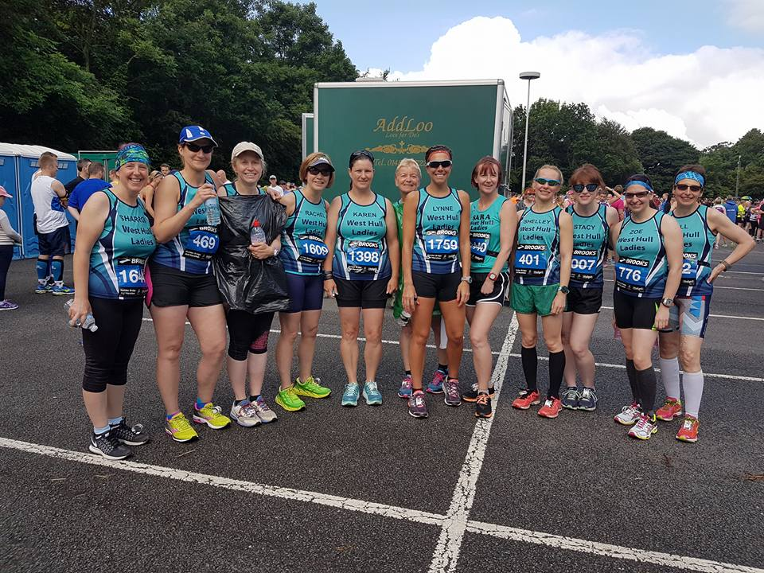

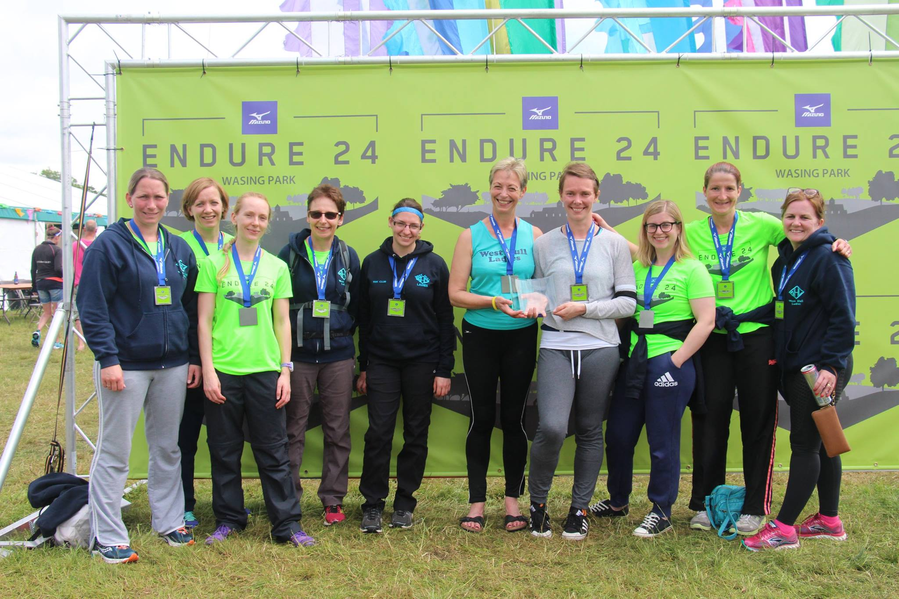

West Hull Ladies
Committee Meeting Minutes
4th July 2016

Present - Jill, Sandra, Amanda, Karen S, Maria, Linda, Shell, Liz

1. Apologies from Jan, Anna, Annette
2. Minutes from previous meeting accepted as an accurate record.
3. Matters arising -
4. a) In relation to the staging of a WHL run in 2017 the idea was put on hold as no one had come forward wanting to take it on board. It was agreed that we should approach a local Club with expertise in arranging events to see if we could help and gain the necessary knowledge. Action Jill to continue. b) Wednesday night training was again discussed and it was agreed that we would try and initiate the ‘buddy’ scheme where ladies volunteered to attend and run with ladies from the Club. Liz D was the first volunteer.
5. Amanda stated that not many members had expressed interest in attending this event on Thursday 7th July. It was agreed to postpone it until autumn. Action Amanda to cancel. (Completed)
6. Maria mentioned a lady who had attended at the Club when she was leading. The lady had never been involved in running before and was unable to run the required mile. Action Sandra to email lady and explain about 0-5k and the one being run soon by City of Hull.
7. KuHAC -proposed Winter League. It was discussed and agreed that as a Club it was not something that we would be able to support by attending due to pressures of other events and work/family balance.
8. parkrun iniative. Shell stated that she had at the weekend run parkrun in Manchester. In order to promote their Club members had put on a cake stall giving away cake. It was thought that this would be a good idea for WHL to try. Ladies would be asked to bake cakes and we could also offer to marshall. A proposed date of 30th July was agreed. Action Shell to contact parkrun to arrange.
9. Shell was thanked for the work she had put in especially in relation to the Hull 10k when funds were raised for the Club. Sandra proposed that she be elected as a member of the Committee and Amanda seconded this.. Shell agreed.
Meet a Member : Diana Wallis
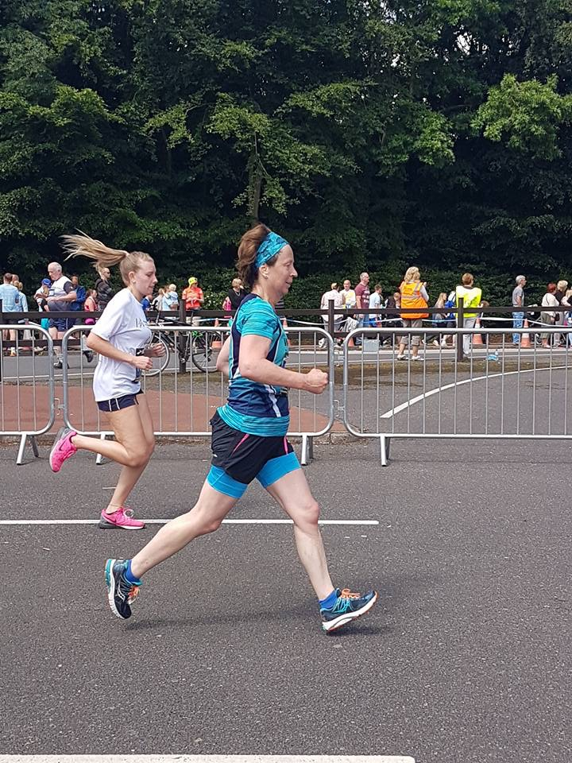

Age 61

Member of WHL since – Sept 2016 – I encountered some of WHL after the Elloughton 10k last year when I had had a rubbish race not having been running properly for nearly two years, and I thought they looked like a great group…

What do you do when you’re not running? – (work/hobbies/family)
Various things to do with law and Europe, otherwise knitting / crocheting are my secondary 'keep sane' hobbies apart from running. I could add gardening, reading and history but then it becomes a bit of a bore.

How long have you been running? - On and off, for about 25 years.

Why did you start running? - I had chronic endometriosis in my 30s, which necessitated a full hysterectomy so I started running as part of getting through and over this, and running has always remained a good friend at the tough times in life

Favourite distance – I don't think in terms of distances, rather places and seasons; I love the foreshore and the water

Favourite bit of running kit - don't think I really have one - but I have found you can never have enough pairs of running shoes.,.

Any injuries? - Until this year I had always remained relatively injury free, then for the first time I was hit by an Achilles problem in Jan but it seems to be resolved now.

Running goals? – There is an ultra trail marathon run every July in the beautiful interior of Iceland - a country I love, it would be special to be to be fit enough to attempt this in the next years before I hit 65 - any takers to train with me to do it?? See http://marathon.is/ultramarathon and by way of example this lady's account and pictures of the race; which will also explain why my husband will not let me contemplate it alone, not sure I would want to anyway! http://rule5.bike/?p=1328 So a 2/3 year project to save and plan for if anyone is interested???

Proudest moment running related or otherwise – Completing London Marathon in 2009 running for Endometriosis Awareness, even though the time was a pretty unimpressive 5 hours 20 mins almost exactly the same as a few years previously. My life has always included too much travelling to really nail the training but maybe WHL can help fix that?

Best piece of advice you’ve received – Not to go off too fast at the start of any race - but then I always do

Running alone or with friends? – Both

What keeps you motivated? – Knowing how much better I feel when I run and how rubbish I feel when I don't

Meet a Member : Katy Stephenson
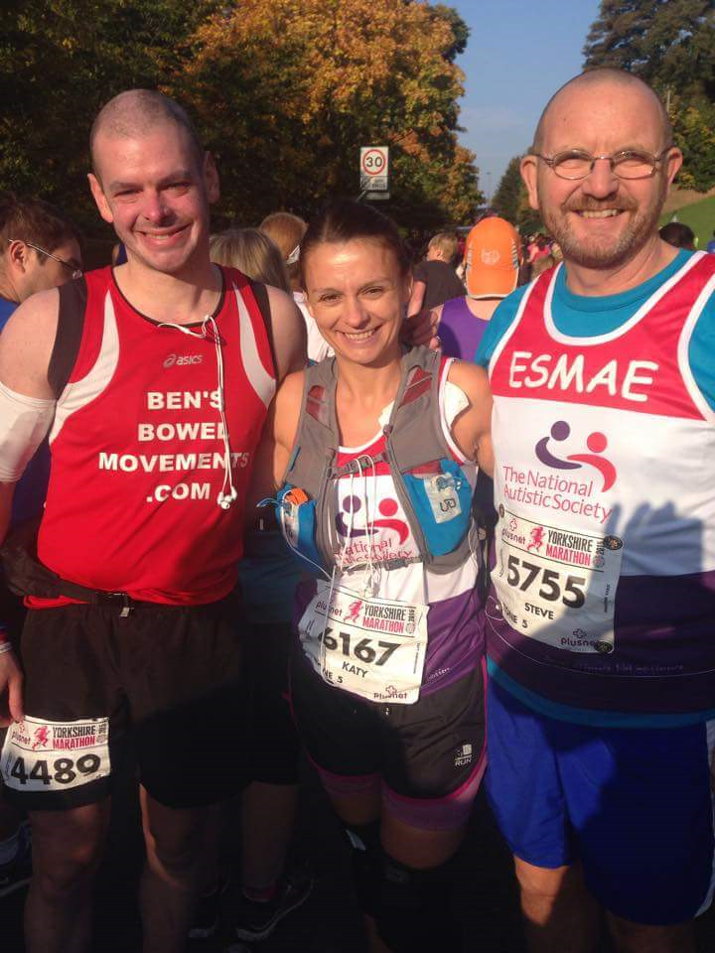
I'm Kate, I'm 42 in August.
I'm married and have 5 children. Ages range from 20 to 3 years. My youngest has severe developmental delay and we are waiting on a diagnosis.
I live in Hessle and when I'm not a mum I'm a specialist neonatal nurse in a very busy intensive care baby unit.
I started running 5 years ago on advice from a psychologist as part treatment for depression, I was never good at running at school and when I started I couldn't run for more than 30 seconds. I've since completed many 10k s a few half marathons and the Yorkshire marathon last October.
I am not a fast runner i never will be, but i love to run it helps me escape every day life, cope with bad times and gives me a sense of power to overcome any challenge I may be facing.
I run for a lot of charities, two close to my heart are mummy's star and hull national autistic society. I have met the most courageous people running my biggest inspiration is a guy who I ran the Yorkshire marathon with he has terminal bowel cancer but has ran 25 marathons in 25 months to raise awareness and sponsorship.
I joined the club late last year then took time out to study for an exam and recently joined again. I've never felt so supported in all my life, there is something special about you ladies the encouragement and support is phenomenal which goes beyond running. I can't always get out of the house to join you all but when I do I always love it.
Kate x

Goole Third marathon Riverbank Challenge: Sharron
Nige fancied this one when we saw it advertised. He looked at me questioningly….”we get a tee-shirt……” he said, “Oh go on then” I said.
After that, I was always looking forward to it as I’d heard reports of how nice this run was. I mean, running along a riverbank, what better way to spend a Sunday morning! Everybody was right though, this WAS a lovely run.
Arriving, we watched the fun run, and cheered in the amazing young runners. I saw Sarah Tock and went and had a chat with her. Then we all walked to the start. We climbed up to the top of the riverbank and waited to be set off.
It was difficult to get going at first. I HAD been warned by Sarah about this. Everyone needed to be in their fancied position as it was very narrow at the beginning and there was also a massive post to avoid in the middle of this path. So, Nige and I split up, he went nearer the front and I wandered nearer to the back.
So, we set off, like I said for the first half mile or so it was quite hard to pick up a rhythm (ooo get me, trying to pick up a rhythm). I overtook a few runners then finally when I was happy with the pace I had got going I settled into the run. I was kind of classing it as a long Sunday morning training run, just done along a riverbank in Goole instead of round and about in Cottingham or Hull!
1 to around 3.5 miles was lovely going. The grass was quite flat, really nice to run on. The houses there on the bank were absolutely beautiful. There were a few people out on the bank walking dogs, wishing me a good morning, wishing me luck. I was having little chats with people and marshals as I was running by them. In my training runs recently I’ve been running with people chatting, so it was very strange today running on my own……….I needed to talk, I was BURSTING to talk after staying quiet for a couple of miles, so everyone wandering the bank copped for my random chatter!!! When there was nobody around to chatter to I just carried on admiring the stunning houses!
3.5 to around 4-ish miles we ran into Goole, it was nice to have concrete underfoot for a while. We were eventually directed back onto the riverbank.
4-ish to 5 miles lasted FOREVER!!! We were running back by the houses, but we were on a ‘lower’ bank going back so I couldn’t get much of a nosey again at the splendid houses. There weren’t as many people about at this point and I felt quite lonely but, I saw one woman and she cheered me up as, running by her, she screamed “Come on West Hull Ladies – I’m from Hull – You’re doing GREAT” THAT put a HUGE smile on my face. During this loooong section to 5 miles I just concentrated on not losing sight of the runner in front. I realised I was slowly gaining on him which spurred me on a little. I caught him up just after the 5 mile marker, had a little chat with him J as I passed him, then concentrated on catching the next person up ahead.
My one and only stop was just before the 6 mile marker for a gulp of water. There were 2 other water stations on route, but I’d brought my own water bottle so I was happy just using that. I’m glad I took this 30 seconds walk to drink (thanks for the advice Karen) as, unbeknownst to me, there was a mile and a half of hard going long grass in front of me……
……so, around 6 to 7.5 miles…….that was incredibly tough; ‘tall’ grass, hard going on the legs. A Beverley AC runner had stopped with me to drink at the water station and we ended up setting off together after our drink. Again the path was narrow, so she ran in front of me and we chattered to one another, mainly to get us through this ‘really tall’ grassy section. We could see the faster runners on the way back to the finish, running on the road to our left hand side. So, as well as the ‘incredibly tall’ grass being hard on the legs, seeing the fasties was hard on our minds as we could see how far round WE had to go to reach were they were now………. But, all of a sudden, I shouted to the Beverley AC runner “Oh, there’s my husband, on the road, just coming in to finish” so, there were us two mad woman on top of the embankment, in ‘amazingly tall’ grass waving and shouting like idiots! Made him laugh and no doubt the people behind us!
So, at around 7.5 miles we were directed up a really steep muddy ramp which lead us onto the road. My first thought was “How on EARTH am I going to get up THAT???” I grabbed onto EVERTHING I could to get me up it and, towards the top, lunged for a concrete post and didn’t let go until my legs had stopped spinning round in mid-air and found stable ground! Up I got onto the road, wow, the relief to be on pavement…..phew……but, that relief was short lived, as I then felt the effort from the ‘terrifically tall’ grass in my legs. We ran toward the roundabout before turning left into the long road which took us to the finish. This road was slightly undulating, I had the Beverley AC runner still in my sights, she over took another runner, I over took that runner too.
I saw Nige in the distance, yay, he shouted encouragement, and I also heard him shout encouragement to the lady behind who I’d just overtaken.
Beverley AC runner turned right into the entrance to take us to the finish, I turned right too. “Not far to go now” several people shouted………..oooooooooooo I HATE it when people shout that. But, do you know, it really wasn’t. You always kind of steel yourself for that last bit, which just GOES ON FOREVER, this didn’t. A quick trip across some more (manageable) grass and there was the finish line.

When I finished, the Beverley AC runner came to me and we hugged, we were thankful that we’d kept each other going through that ‘extraordinarily tall’ grassy area and the run in to the finish.

I collected my tee-shirt, met Nige, had a coffee, then we drove home.
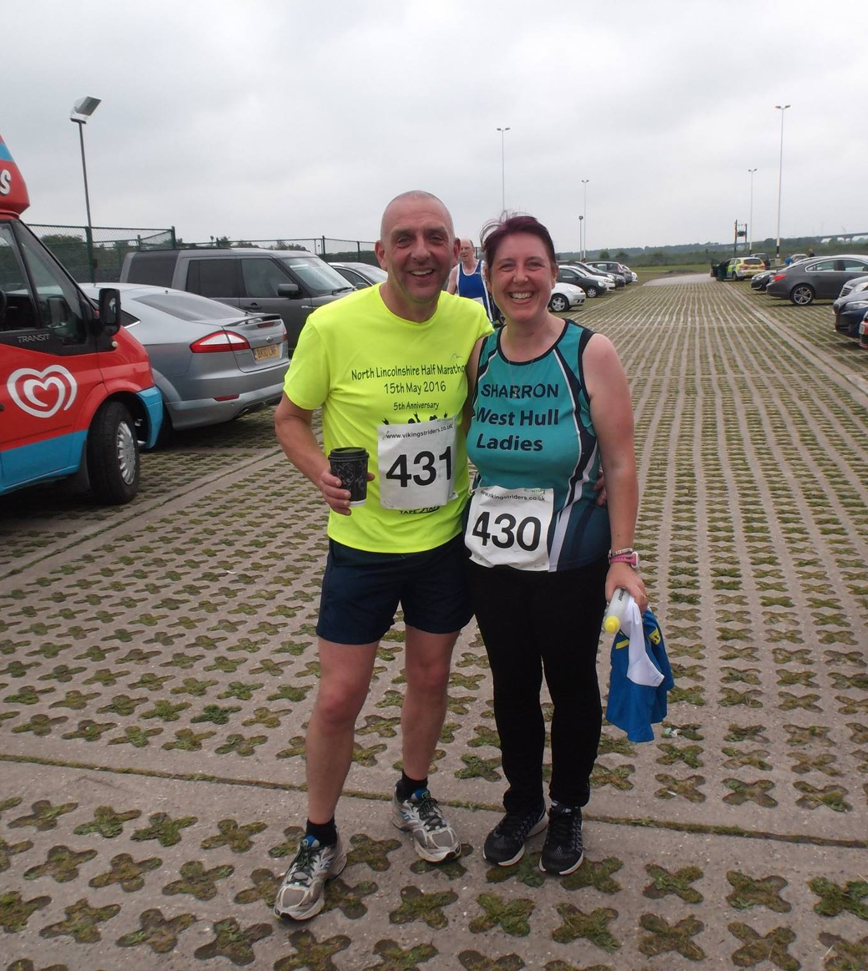
I really didn’t have a time in mind. Like I said, this kind of started off as a training run. When I struggled in the grass I just altered my speed and then when I felt the relief of tarmac I sped up til until my legs found a comfy speed again.
I finished it in 1 hour 33 minutes. So pleased with that as from 6 miles when we hit that ‘AMAZINGLY FAST GROWING GRASS (according to this report - ahem)’ I knew what the expression TO DIG IN meant!!!! Literally!!

I would DEFINITELY do this run again, I really quite enjoyed it.

Brathay Windemere Marathon
and
Skye half Marathon: Ros
I have completed two of the most scenic races recently, the Brathay Windermere marathon in May and the Isle of Skye half marathon in June.
It's at long last that I have completed the Brathay Windermere marathon following last year's incident when I had to pull out at 16 miles as I was hobbling and in immense pain. Since then I wanted to go back and finish it and a year later I did.
My mission was to make sure I completed it and not worry about getting a fast time. As expected it's a hilly route and my watch totaled over 1600 feet of gained elevation. Since last year's injury I've been running a lot slower and making sure to stretch my very inflexible ankles that cause the pain. I made sure to keep a steady pace, 10 to 10.30 minute miles as I didn't want to risk not being able to complete it again.
It was a very sunny and hot day, and it only cooled as I ran through the wooded parts in the first half. There was an abundance of wild garlic along the route that masked the usual scent of sweat and deep heat. Still not sure if it was a good thing or not.
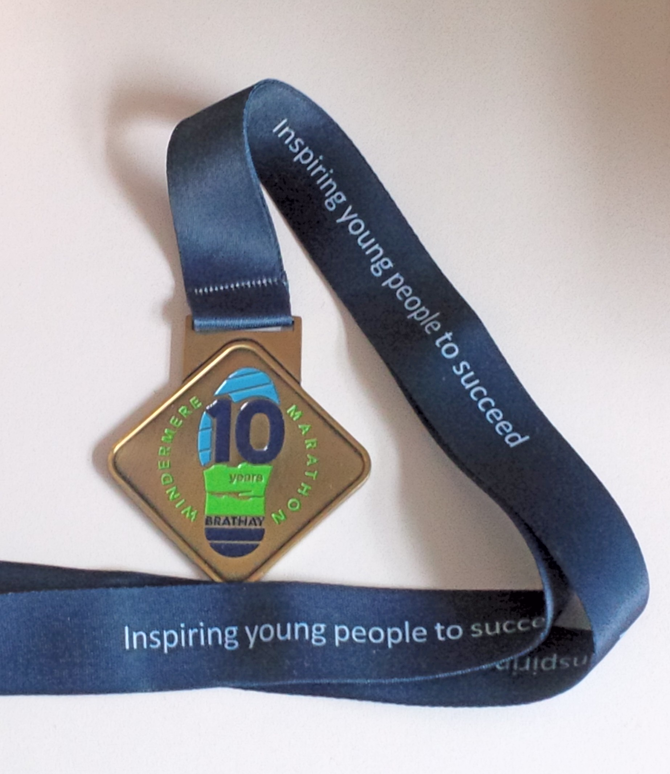
It felt strange repeating the first half but at the same time it was great as I wasn't feeling the pain I had done previously. I felt as though I was running with a massive grin. Although I was nervous as I approached mile 16, I felt good for getting to this point without any pain and knowing there were another 10 miles to go. It was also the start of sections were it was quicker to walk bits of the hills. The second half is on roads open to traffic and there were a couple of scary moments with coaches on narrow roads and nearly getting squashed!
There's a few steep climbs but sadly not as many downhill parts, if anything they flatten out before going uphill again. The last stretch of uphill towards the finish is evil and another lady was also cursing it, so we had a laugh as we walked/ran up the last bit before running to the finish line. I finished in 4 hours and 57 minutes, so pleased it was within 5 hours.

Second scenic race - Isle of Skye half marathon
There were 3 weeks between races and I very nearly wasn't able to do it. After the marathon I woke up to find fresh bruising appear above my right ankle. I wasn't able to do much as I was driving back home and after a 3 hour drive I was able to raise my ankle and ice it as it had swelled and was bright red. The pounding from the marathon had resulted in a light sprain and meant the first week I had to keep my ankle raised as much as I could and iced on and off for 72 hours. It was very sore and in the week the swelling had gone down and bruising had gone. I wasn't able to go running and after another week of rest I did a bit of cross training on the bike. It was only the week before that I did my first run and had to stop after 2 miles as my right foot was sore. This worried me and I decided to rest up and see how I felt on the day.
I had wanted to do this race since I first heard about it around 6 years ago when I was living in London. The very small stubborn part of me wanted to complete it no matter what and again I had in mind to run instead of race.
The day I traveled up it was sunny and hot, reaching 25 degrees in parts of Glencoe and in typical Scottish tradition, it rained the next couple of days. Race day was drizzly, humid and little wind for the first 9 miles, perfect midge weather. I counted 24 bites the day after.
The first steep hill is within the first mile and then a steady climb to mile 3 and then it's up and down to mile 6 where there is another climb up to mile 8 where it levels out. The steepest hills are between 9 to 11 and then you descend back into Portree, overlooking the bay and mainland. I was so pleased there were plenty of water stations as it was hot and I had my first drink at 3 miles, which is unusual for me in a half marathon.
They also had SIS gels at mile 9 and the flavour was pink grapefruit, which is my favourite. I was so happy and I think my reaction made the marshals giggle.
I finished in 2 hours and 13 minutes and really enjoyed the route. The start and finish is at Portree's secondary school and the organisers provided free food and showers to runners. It was heaven and loads of different homemade soup, I had lentil with a buttered breadcake and there were lots of homemade cake. I choose a lovely piece of ginger cake and a piece of carrot cake.
I discovered that the race is part of the Heb 3, a series of 5 half marathons in the outer isles and to qualify you have to complete 3 in the same year. I think this is next years challenge.

Endure 24 : Jan
‘Like mother, like daughter’: Mother’s account of Endure 24

It was Liz’s idea – honest! Endure 24 in 2015 had whetted our appetite. We’d both run in different teams of 5 last year and thoroughly enjoyed it. I really like the 5 mile course – a good mix for me of trail and path and lovely peaceful countryside – and a great event that is well organised.

As the day drew nearer I was worried I hadn’t done enough training and, as you all know, Liz has been on a roll and running so well. So I was a little worried that I might not be able to keep up with her and let the side down.

We had talked briefly about tactics and decided that, from the outset, we would do double laps of the course which would give us longer in between to refuel and rest. The strategy for the night time was to do triple loops which would give us the opportunity to get inside sleeping bags and try and get some sleep.

The strategy seemed to work really well and we both got a number of double laps under our belt. A crucial aspect to an event of this nature is not just doing the miles but making sure you get your fluid and nutrition right. Thanks to an abundance of food in the WHL base-camp, a diet of rice cakes, humus, boiled eggs and flapjack seemed to work for me. I was relieved to be able to keep food down without getting a stitch, something I suffer from quite easily.

During my 6th lap (3rd double loop) around 11pm as I was getting ready to hand over to Liz for her night-time triple, my right knee started to hurt. I’ve never had any problems with knees before so was a little worried. Fortunately, I had 3 hours off course to look forward to and, after something to eat, got inside my sleeping bag to get some shut-eye. When I got up for my triple, my knee was so sore I was seriously worried that I’d have to pull out. I told Liz I’d walk a double loop and see how I felt. At that point we were 1 minute behind the leaders. I started walking and thought ‘this is going to be a long night!’ But then I gave myself a good talking to and thought that if I could complete the Osmotherly Hardmoors Marathon (29 miles with 4500 feet of ascent) I could do this. So I dug deep and started to run again. In fact the knee was no more painful running than it was walking, as after a while I think the endorphins kicked in. So having anticipated that it would take me 3 hours to walk the double loop I was back within 2 hours having run it. So Liz went out again and did the dawn shift.

At this stage I think we were 20 mins ahead of the 2nd pair and now my mentality had totally shifted from enjoying-this-and-having-a-good-time to blooming-heck-we’re-in-with-a-chance-of-winning-this! And so Liz and I continued to do our double loops throughout the morning. I did the last lap, finishing about 11.45am when we were about 40 mins ahead of the 2nd pair. We thought we’d done enough but we were both a bit anxious until it was confirmed. In the end we were 1 hour and 26 mins ahead having done 24 laps and 120 miles (Liz 65 and me 55).

It was such a great achievement and beyond anything I had imagined. It was fabulous running with Liz – I am so proud of her steely determination – she really does spur me on to achieve more than I think I can. The informal presentation was a lovely occasion, celebrating all the pairs’/teams’ achievements. And it was a great moment for mother and daughter and for West Hull Ladies too.

And we didn’t fall out once!

Endure 24 : Liz
When I signed up for this which seems so long ago now, Jill had told me “You WILL enjoy it!” Only my sister could make this simple phrase seem like a threat. I was thinking about this as I drove to her house with all my gear. I guess I would either love it or hate it!
We had decided to set off on the Thursday to stay in a Travel Lodge, with Zoe, and then set off early to claim a good camping pitch. This all seemed perfectly simple in the planning but we had not reckoned for the sheer amount of things we were bringing, both of us having brought camp beds as well as all the other stuff. I think it's safe to say that we probably broke the world record for sheer amount of camping equipment in a Ford Focus. We had a number of attempts at getting everything in and finally managed it with a few none essential omissions. Then we went off to have lunch. I have to confess I half expected the car to have exploded when we got back out to it, and it took me some time to actually fit myself in the front seat because my little short legs had to share the foot-well with a coolbag rucksack, this seriously threatened my right foot with frostbite throughout the five hour journey! Apart from a traffic jam, our journey was uneventful although poor Zoe nearly starved to death waiting for us to bring lunch.
We had a decent night's sleep and I woke up to the sound of Jill and Zoe singing Happy Birthday. In all the excitement I had forgotten about the date. I also realised I had forgotten to pack my deodorant so I bought some from the motorway services, after having borrowed Jill's in the morning. After breakfast, we set off to the Endure site. We got there an hour early and were able to leave the cars in a queue to check out the site, establishing about three possible field areas which would be suitable. In the event we got a great position also we didn't get any other groups sharing until later so we could spread out. I have to say that we made a great tent erecting team, Zoe quickly taking on the role of patrol leader with me and Jill as willing team leaders. Zoe had got it all worked out and we were able to get three tents up including the Event Tent which, despite Jill and Zoe's lack of height and my little short legs, we were able to put up with the aid of Linda's brilliant stool (an item which should get an honoury WHL team membership). We stopped for lunch and tea, followed by Ice Creams as it was hot work. We also picked up the numbers, ASBO tags, and t shirts for the rest of the team.
From about 2:30 onwards the rest of our team began to arrive and the camp began to take shape. We were especially proud of our new banner, brought in by Liz Draper, which was the biggest one on the site; WHL had certainly arrived! We worked out who was going in which tent and realised that with Shelley, Jane and Frosty arriving later no more tents would need to be erected. We went for a walk to look at the early part of the Endure Route and then had some dinner which Jill had cooked . When Shelley arrived she bought me a birthday hat and some lovely cakes as well as Bucks Fizz and Cava, it was really a birthday to remember and lovely to spend it amongst my lovely WHL “sisters”.
I slept quite well so the camp bed was worth it! However the day didn't start well when I discovered the hard way that the “deodorant” I has bought was actually shaving gel! It's amazing just how far shaving gel can go when you spray it like deodorant. Luckily Sarah K had forgot her toothbrush and so she went on a shopping trip and got some for me. After I had cleared up the mess, we went down to the start area to have a look at the stalls, shops and write on the Endure wall. Jill bought me a bespoke WHL blue halo headband for my birthday.
We then returned to camp and discussed what order we were going in. My team was Sarah K, Sally, Sandra and Jane. All of my courageous team members, apart from me – cowardly me – were going to do double laps in the night. It also transpired that I would race first. (I had mixed feelings about this as I really hate waiting around but was quite nervous about being first up). We also worked out approximate times for our runs which we would tweak as we came in with the actual times. This caused some issues as the times varied at just under and over the hour mark and our maths skills took a while to be up to the job. Why don't we digitalise the clock it would be so much easier!?!At last it was nearly time to start, I have to say that the pictures of me at the time show my nerves. Rachel and Liz D where also to start first for their teams. We took selfies and after a wait, that was as long as always, we were off.
The course was 5 miles a mix of on and off roads and some wooded areas. It's a lovely course but probably more hilly than I had been told. I am starting to realise that more seasoned runners have a different idea of hills to my idea of hills! The marshals were lovely and very encouraging. About half way round there was a strange hippy-like person with a VW camper van, playing loud music and I think giving out some kind of energy shots. I decided to stay clear of this person while wondering if Jill had put some kind of magic mushrooms in the bolognese! However other people saw him which did make me feel better. There was also a drink station just before a really steep hill. At this point I was wondering how hilly the Thunder Run course would be as Zoe says “Thunder run IS HILLY”. There were some tricky tree root bits as well as some downhill bits which were a bit scary. There was also some kind of shooting going on in the distance which made me worry that they were picking off the later runners! I did do my fastest time on my first run..You then return back to the main field and into the busy change over area were you are frantically trying to find your next runner, in this case Sarah K. Some of the teams have a toy sword or flag so they can spot each other. I spotted Sarah and she passed me my hoodie and set off while telling me how to get off the course, something I hadn't really thought about before.
Then it was back to the tent where I had to remember to write in my time so the team could work out when they need to set off. Now it was time for a change of clothes after a shower. The showers were really good, by the way, but as the event goes on more queuing is involved. I then had to wait for my next turn,but decided to pop out to take some pictures after fuelling up. Food is interesting as you don't really feel like eating too much. I have to confess crisps and scones turned out to be my food of choice as well as tea and water for hydration! Sally found the waiting a bit tricky as she has done a pairs team with Zoe before so the 2-3 hour gaps between runs seemed a long time for her. After Sarah K, it was Sandra, Jane and Sally and then back to me. In my case when Jane came back I needed to start to prepare for my run. You can sort of see when your next run will be by looking at the timings of the other runners. Ithen made my way out for my second run, watched out for Sally then changed over.When I look back now I find it hard to remember what happened in each run. I was happy that I felt okay and on some occasions I would chat to the other runners. There is such a brilliant atmosphere and great camaraderie amongst the runners. The speedy ones are very encouraging as they fly past you and some of the slower runners are solo runners who are just awesome. I had to laugh as some of the runners asked me how many I had done I think because I am slow they thought I was a solo runner! Some people power walk the event as well.
When I got to my third run it was starting to get dark and I ran with a head torch, this was good, but I was bothered by the flies attracted to the torch. There
were also some very enthusiastic jolly fairies in the woods on a night time and they scattered fairy dust and had put christmas lights in the trees. The strange
hippy-person was still there as well, his camper van was lit up with all different colours.
I changed over to Sarah who, along with my other team members, was starting a double lap. I was lucky in that this meant my next run would be about 4am so
almost a normal night for me. Sandra was doing a double lap and then setting off home during the night.
Just after I got back Jan came in a bit of a state, it's the one and only time I have seen Jan not looking glamorous. She had fallen on her knee which she had damaged a couple of week before. She went off to the showers although, in the event, there was a queue so she used the wash basins in the toilets. She was a bit worried about her knee. We walked back together and then made tea – the solution to all problems in my view! Jan was worried as her and Liz were doing pretty well and were in 4th place. Jan went off to strap her knee up and borrowed a “cold” bandage of Jill's to do this.I went to bed. I was woken by Jane at about 2 in the morning, the runner before you is responsible for waking you up. I was completely disorientated and
nearly ended up in Shelly's “room” as I frantically tried to remember where I was. I had loads of time really as I was next up about 4am but at first I was madlyracing around, not sure why, as I had slept in my racing gear. I went off to the loo and was struck by the activity in the camp site at this time. Everybody walks like John Wayne with stiff legs and it's a particular “24 hour race” walk. There were also tents where massages were going on. This would be regarded assomewhat dodgy at 3 o'clock in the morning in polite society but was completely normal in a 24 hour race!
When I returned to the tent, Jan came back earlier than anticipated in great pain from her knee she had to wake Liz up to start her next stint early. I'll never forget the fact that as Jan sat down quite upset Liz just poked her head in the event tent and stated calmly, don't worry I am on to it I'll keep running just change over when you can, she looked as fresh as a daisy. Liz, you are just amazing! I made Jan some tea as she worried about “letting Liz down”. If I remember rightly I told her I thought she was awesome and she mustn't worry. I think she felt a bit better and I hope I helped a bit. She then went off to sort her knee out and take painkillers etc.I was then up for what was my favourite run, taking over from Sally. She had ran round with Jill who had fallen as well. I wished Sally “good luck” I am not quite
sure why as she was just going back to the campsite. I felt really good as I love running in the morning. That morning it meant I saw the sun come up. I managed to take a picture and saw Frosty come past me. Jill's team were doing well and in about 4th or 5th place. I really enjoyed that run, I felt I could do atleast another two laps.
When I finished and handed over to Sarah, I saw Jan in the changeover area and she looked pretty good. I am not sure if it was the painkillers or taking off the bandage that helped but she was in action again. They had also found that Jan and Liz were in the lead so I am sure that helped to spur her on. Once I got back, we discussed further laps – I was hoping to do two more. Everyone was really excited for Jan and Liz and also Jill's team was in with a chance of a place so the mood was great.
My next lap was a disaster somehow I went from feeling epic to rock bottom. I got a pain in my left hip and was worried that it was an old injury that I had before. In reality it was probably IT band trouble and general tiredness. I was okay on the flat but couldn't run up or down hills. I therefore walked most of it. It also didn't help it was raining so I was getting soaked as well! The awesome Liz caught me up and got me to run with her to the water station. Again I was in total awe of her, she honestly looked as she did at the start, she is a machine! I rang through to base camp and said I wouldn't be doing anymore as I was a bit worried that my team members might have only been doing another lap because I wanted to do another one. I wasn't even sure there would be a change over. As I came into the area, it was so wonderful to see Sally and Jane, it brought tears to my eyes. We had a lovely WHL hug before Jane set off for our last team run. There was great excitement back at the camp. Jan was there and she was looking happy, I don't know if it was because they were still in the lead, the painkillers she was on or the flat Bucks Fizz she was sipping straight out the bottle! She was about to change over to Liz. At that point I knew they were likely to do it, because if need be Liz could get an extra lap in, and I'd just seen how strong she was.Jill's team were also hunting a place, if Rachel was to get back in time they could possibly get an extra runner on the course before the 12 o'clock deadline. After a rest I felt much better and grabbed my camera so I could get some pictures of our last runners. I am so pleased to say I did because I got some great pictures which really summed the event up.Liz was up at the waiting area looking at the results to see if she needed another lap. As it was she knew they had done it! Sarah K positioned herself to give Jan an extra cheer as she came into the field. I managed to take pictures while shouting “Champions” at her football chant style! Then there was Jane finishing for our team she looked so strong. Finally as Rachel was on the course after the 12 deadline Jill, Zoe, Frosty and Shelly were able to join her for a final lap of honour. They had valiantly come 5th I think.
It was wonderful seeing all the other teams and solo runners finishing everybody got a great cheer it was a great end to a fab event and I was quite emotional
watching everybody. There was one guy who was virtually finishing on one leg and hopped over the finish!
There was a bit of a wait to the prize giving so we started to pack the campsite up. The prize giving was ace, although I felt that they should have awarded team prizes for 2nd and 3rd not just for first. It was an awesome achievement by Jan and Liz but everyone achieved something. It was a unique experience and I shared it with an amazing group of ladies and I have some excellent memories. After the clearup we said good bye to everyone and returned to the travel lodge which was probably just as well, as Jill who would have been driving, spent most of the evening asleep! Me and Zoe talked into the evening and we travelled back on the Monday.
All in all a great weekend where I learned three things: You can get an amazing amount of stuff into a Ford Focuss With more training I think a marathon is possible for me,,Shaving gel makes terrible deodorant!
You were right Jill I DID enjoy it!
Humber Bridge Half : Sharron
I entered this off the back of a good run at the North Lincs half. I knew this one would be a lot harder, I had done the recce's. I knew about Cardiac Hill from the recce's. I had prepared for it as much as I could, but unfortunately I came down with a stupid niggle which meant that I had to rest the two weeks before the run.
Anyway, I had rested and the day came, I was thankful I was there as, just the week before, it was doubtful I'd be at the starting line. I had two aims with this half; 1) I just so desperately wanted to finish and, 2) I just HAD to run and not walk up THAT hill.......
Off we went, I set off all happy, relieved to be there. Saw some people around me who I knew and had little chats with them, I think I started this half as I meant to carry on.......to enjoy it. I was aiming to take this steady, aiming to finish.
There were lots of people supporting, it was really nice to see. There were loads of people down Boothferry Road and on the run up to and over the bridge. I remember doing a lot of smiling when people I knew, and all the WHL who came to cheer us on, called my name. It was really lovely.
Jane and I seemed to run alongside each other from early on in this half and we ended up running most of the half together. We didn't talk much, but we were there side by side and that was very reassuring.
I LOVE running over the bridge, so I really enjoyed the first 4 miles or so.........hmmm, little did I know that, THAT statement would come back to bite me on the backside on the run BACK over the bridge.............
But, stupidly, what I'd forgotten about was the slip road up to Barton. I knew that the bridge ended 'somewhere' and Barton started 'somewhere' but I'd somehow erased from my mind the bit between the 'somewhere's!!!'......there was just a gap in my head......no jokes please!! I started uphill.......huh?.....what was going on here, why are my legs getting tired so soon.....WHY ARE WE GOING UP HILL.....?????? Oh yeah, then pixels of road started to build in my mind, filling the gap between the bridge and Barton. Duh.....I'd forgotten about this. I made it up the slip road, I was certainly not stopping.
I carried on. Running through Barton was nice. There were lots of people out supporting, loved it! I tried my hardest to thank everyone who shouted encouragement, if I was so tired I could not talk, I tried to smile......which probably came out as a grimace..... all the while remembering my vow that 'enjoyment' was the 'word of the day'. I remember running by one chap relaxing in his deckchair watching all these mad people running up and back over the bridge on a warm day. As I said, he was sat relaxing with a cold drink in hand. We approached, he caught my attention; "Go on Sharron and Jane" he shouted " Gooooooo onnnnnnnn" then quite unexpectedly he jumped up out of his deckchair, waved his arms in the air like he just did not care ;) and shouted "Look everyone!!! It's Sharron and Jane, it's Jane and Sharron, EVERYONE LOOOOOOOK!!!!!!!!! G'woooooooooon you two, G'Wooooooooooon" It was so funny, so surreal.......I really did do a belly laugh, so funny. The really funny thing was that everyone round about him started cheering us on AS WELL!!!!!.......Bizarre!!!!
I remember thinking when I hit the half way mark, that the lack of training two weeks prior to this, was beginning to tell. I knew that cardiac hill was approaching, I was still determined to run up the devil. Jane and I approached the last water station before it. We stopped to walk and drink and gather all our inner strength to tackle the hill. Right, off we went.
From the water station, we ran down the road then round the corner, Cardiac Hill presented itself ahead......right then you little ************ let's be having you!!!!!
I set off, ok at first, maybe a little too fast, slowed down a little, everything felt ok still. Quarter way up legs tiring now, 'I'm not stopping' I told them. Half way up, encountered loads of people walking, 'you're not walking' I told my legs....'deal with it'! Three quarters of the way up, legs are singing quite a lot, 'however loud you sing' I told them, 'you are still not stopping'. More people were walking. Nearly there now, nearly at the top, my legs were SCREAMING, 'just carry on a little longer' I screamed back. My brain was telling me that I WAS running up that hill, whether I was in reality....who knows! Legs really really tired now, and............Yay!!! I'm at the top!!!! I DID IT!!!! So happy!!!!!
At the summit I stopped to look back, to see what I had just conquered, I was so happy. I took time to have a little bite of food to get the energy levels going again. And off I went. Jane and I had split up running up the hill and as I turned to make my way back onto the bridge I heard a little voice behind shout "Sharron....Sharron", and up ran Jane! :)
Now, earlier on when I said I LOVE running over the bridge, I now looked at the bridge as I ran towards it and thought "How the dickens am I going to get back over THAT??!!???" Those last 2 miles back over the bridge were awful. It was so hard running back. It took every bit of my strength to get back over it. It was so hard, I just wanted to hit the finish line and soon! It didn't seem as though I was eating into the last couple of miles at all!
I remember us seeing 2 people 'unwell' on the bridge and being seen to by medical personnel. It kind of made me think and I remember saying to Jane, that I was going to take it really steady these last 2 miles in to the finish. The weather had turned really warm, there was no avoiding the sun on the bridge, I also remember saying to Jane and some other runners who had caught us up; "it's not easy is it...................." There were then a lot of replies of "no, it really isn't........."
That last half mile was a killer! At least there were more people at this point cheering us in......but.......WHERE WAS THE FINISH.....???????? Round this corner, round that corner.....the finish??......Nope!!! Round another corner, the next corner....the finish???....ha not likely!!!! Corners seemed to go on FOREVER..................FINALLY............THE FINISH!!!!!! Jane grabbed my hand and over we went..............phew! did it!!!!!!!!!! I happily collected my medal AND a tee-shirt, how fab, then a lolly, an apple, a banana....... Never has fruit tasted SO nice!!!!
Very very pleased with my time. 2 hours 23 minutes. Quicker than I thought I'd do it. I just wanted to finish, and I did.
Like I said, pleased Jane was by my side, very reassuring.
It was lovely to see all the other WHL at the end.
Well done to everyone, this one was a toughie!!!!
P.S. I couldnt walk for 3 days!
Humber Bridge Half : Ann
I first ran this two years ago, in the pouring rain - we were soaked through before the race even started. This would be my second half since returning to running this year, but the previous one was North Lincs, which was much, much flatter. I realanted a sub 2 again, but to achieve that on a much hillier route was going to be a challenge. Not only that, but I'd only ran up Gravel Pit Lane once in training ... not the best preparation, but it'll have to do.
Living nearby I was lucky enough to get a lift from Carol, who dropped me off just 15 mins before the off. No toilet queues, just warm up and then go! That was a nice touch for the start of a race.
So off we went - its a funny race, it starts with a bit of an uphill, and then a down, and then a bigger up, and then it levels out over the bridge for a while, so it takes a while to get into a rhythm. I thought I had - happily running over the bridge, and then down the hill at the other side, until the pain in my side got worse and worse. I got to the point where I was wincing and moaning with the pain, and running slower and slower to try to ease it. I hadn't even been running hard so I wasn't out of breath. I've had stitch before, and found that if I ran tall, and took really deep breaths it would pass, but not this time. I was in so much pain, I found a medic and was ready to turn around and walk home. The medic didn't say much, but offered me a drink. Linda and Jill passed by, looking worried ...
Having stopped running the stitch eased up so I decided to give it another go. As soon as I started running the pain started to come back, so I decided to run hard up the hill into Barton, and if it got as bad as before I'd just pull out once I was in Barton and walk home. The further I got up the hill the better I felt - quick 'hello' to Linda and then I pushed hard to get to the top for that wonderful downhill stretch into Barton. This bit was great - so fast, so easy - it made me feel really fit. I caught up with Jill at this point and we had a chat. The trouble was, she could maintain this pace on the flat, and I couldn't, so she pulled away.
And so the miles chugged along - I was happy to be keeping under 9 minute miling, and felt quite strong. I liked running through Barton - there was a good atmosphere, and plenty of support, including Sandra - I think she achieved bi-location that day, she kept popping up everywhere. Sandra - you're ace!
And then the hill! I was ready for this and I had a plan, and I invited the runners around me to join in! The plan was to overtake 10 runners on the hill. At first I ran with a couple of guys, but then they dropped back and a Fit Mum joined me, and I was picking them off as I counted down. In fact I got to 10 before I'd run even a third of the hill, so that was a boost. I pushed hard, caught up Jill (yes!), and even overtook an ironman triathlete towards the end. I'd spotted his ironman tattoo on his calf, and when he was getting slower and slower I shouted, "C'mon, ironman!" and got him to up his pace a bit. We crested the hill together, and then off I went.
The downhill bit after this was fun. It was a narrow path, but I was on a mission, so I recklessly overtook quite a few runners by passing on the rough verge, with full confidence from all that gym training and strength exercises that my joints could take it - they could.
Eventually the pull back onto the bridge was good, I don't think I've ever felt so strong at that point in a race before. It was a great feeling. In fact when I crossed the line, I expected that sick, faint "just keep walking, don't throw up" feeling, but all I could do was smile - one great big cheesy grin, because yes, I had not only beaten my last time for this race, I'd also gone sub 2, and beaten my North Lincs time, too!
Happy Days!
Ann
P.S. The stitch? What was all that about? As ever, I turned to Facebook, and the 'Hull Runners' group. I had a variety of suggestions, but the one I will go with was dehydration. I had drunk less than a cup of water before the race, and only a couple of sips at mile 2, so I reckon that was what caused it. I also have some strategies to try next time it hits - breathing on a different leg (?), pressing on the side, stretching my arms up ... I'll have a crack at them all, no doubt and report back!

Withernsea 5 : Sharron
Thoroughly enjoyed this one! For so long I’ve been doing steady runs, concentrating on distance over speed because of the half marathons I was training for, then, all of a sudden….No Half Marathons to train for!!
So, I met up with other WHL at the start on the promenade, had a photograph taken, chatted for a while, then we were off!
I just KNEW that I was going to basically run and see what happened. I had no race plan….!!!
I set off. Kept up with everyone else, first mile there were a group of us just running side by side. Felt good, my legs knew they were in a race, I just wanted to give them a good blast, see how fast they could go.
2nd mile, the big group of us who had started together had lessened, there were just half a dozen of us now. We all felt comfortable running together, my legs still felt ok going the speed they were going.
3rd mile, was feeling the fast start so when my breathing and legs felt slightly off, I just slowed down a little, got myself back in rhythm, then sped up again when I felt comfortable. Unfortunately, I didn’t much like this section, the 3rd – 4th mile seemed to go on forever. I remember it from the one and only other time I’d run this race, didn’t like it then, don’t like it now! It was so long, I kept reminding myself though that after this 4th mile there was only 1 mile to go!
Last mile, here we go………running back towards the seafront. Legs still going strong. Started tiring though with around half a mile to go. Come on, carry on, I urged myself, nearly there, just round the corner……….
Another runner caught up to me and with only around 300/400 metres or so to go, started up a conversation. Yup, a proper conversation. A conversation whereupon I had to actually answer the questions she was asking me. A conversation at the same time that I was trying to ‘kick’ for the finish……….after the 3rd or 4th question, I can’t quite remember which as I’m SURE I was delirious by this point due to:
a) Trying to talk
b) Trying to think
c) Remembering to breathe
d) Remembering how to put one foot in front of the other whilst being interrogated
So, after the 3rd or 4th question I actually said, with a smile on my face “I’m sorry, that’s it, that’s all I have, I have no more, I can’t talk, I need to breathe” She laughed at that, which made me laugh at that, then she gave me a little encouragement to keep me going to the end (which was nice) and she ran on ahead……….
So, back to concentrating on the finish. Come on Sharron, you can do it, I followed the lady who had chatted to me, I saw Nige on my left taking photos, managed to wave and look as though this fast pace was natural to me…. ;)
Over the finish line I went, my time being 47 minutes 51 seconds. Wow, for me, that is quite fast. So pleased with that. Last time I ran it I did it in 54:22, so a 6 minute PB. I really enjoyed giving my legs the blast out that they’ve needed for so long.
It was nice to cheer in everyone else, then see most of them again in the (massive) queue for fish and chips!

A few points to end on;
a) What a lovely way to spend a Sunday. A run along the sea front AND also in the countryside
b) Free fish and chips….although I don’t eat fish, so this is why Nige came along, he’ll do ‘out for food that kid
c) Finally, the best compliment of the day……..???? Nige to me; “I was surprised when I saw you running in. I didn’t expect you at the finish line so soon”
Ah……bless……sigh……….
Sharron

Withernsea 5 : Anna

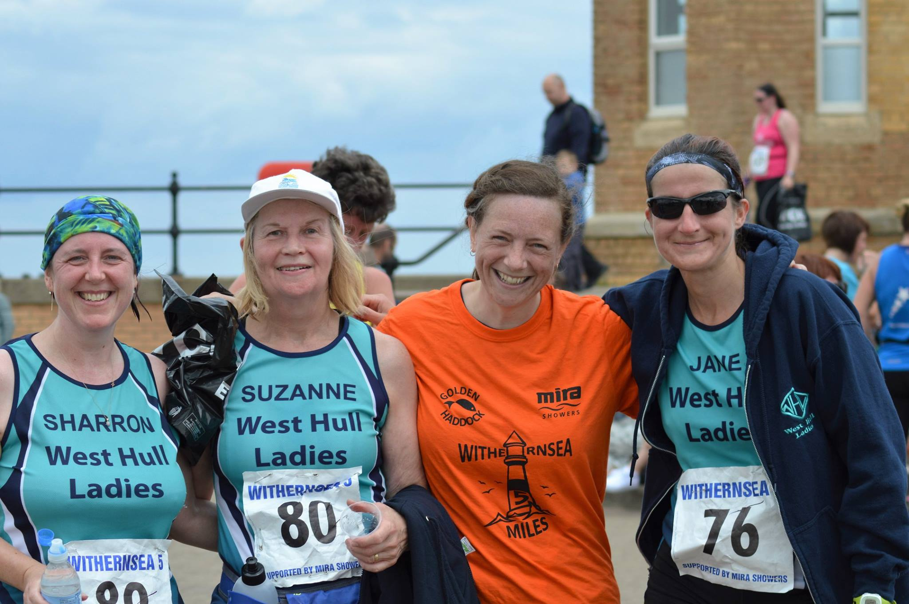
You all know that I LOVE this race. 5 miles is a perfect distance, its by the sea and its all home ground for me- growing up in Withernsea.
I am definitely a city dweller, but always feel great just getting out of it for a day- and as soon as I had faffed about at home working out whether I was taking a child/ husband/ both/ none, I was off driving through fields and open skies- bliss. I drove down the back road to make a little detour to the church where I got married (Holmpton), having to stop for a very handsome hare who sat in the middle of the road looking straight at me- as if I was completely in his way and what was I going to do about it!
As a result of my extra visit, I was rushing slightly at Withernsea, but still had chance to meet those from the club and be reassured by everyone. This is actually one of my favorite parts to any race. I know I appear to be flustered and nervous, but meeting up with everyone at the start and finish always makes it a great day out.
I thoroughly enjoyed the race itself. The route seems to be in manageable chunks- each stretch is just long enough before it changes meaning that there is no time to get bored and it keeps you motivated.
It was however, very hot, and I got a bad headache half way round. Note to self- a hat would be a good plan next time. And plenty of water at the water station.
The run felt great- I was happy with my pace, and it turned out to be a lovely strong and steady race. There were 4 of us pretty much the whole way round, and one lady turned on the way back in along the prom and said to me- “beautiful isn’t it”, and I agreed. I replied that I couldn’t think of a better way to spend a Sunday morning. I still can’t.
Anna

Recipe Corner
Date, Apricot & Coconut Flapjack

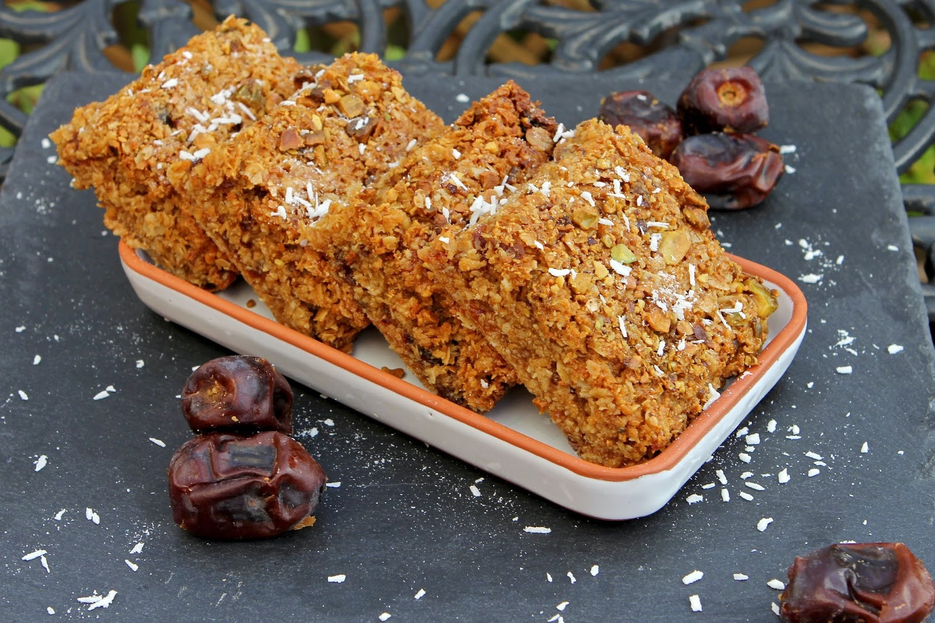

Ingredients

80g dried apricot - chopped
70g dates - stoned & chopped
60g desiccated coconut
80g unsalted butter
150g coconut oil
150g honey
175g soft light brown sugar
300g gluten free oats
handful chopped pistachio nuts

Method

- Base-line a 20 cm/8 inch square baking tin with baking paper.
- Chop the dried apricot and dates and mix with the coconut. Set aside.
- Pre-heat the oven to 150 C/300 F/Gas 3.
- In a large saucepan, melt the butter, coconut oil, honey and sugar over a low heat, stirring well to combine.
- Remove the pan from the heat and add the oats and fruit. Stir thoroughly.
- Spoon the mixture into the baking tin and push into the corners. Smooth the surface with the back of a spoon.
- Sprinkle a handful of chopped pistachio nuts on top and gently push into the surface.
- Bake for 30 to 40 minutes until the edges are beginning to brown and the mixture has firmed up.
- Remove from the oven and leave to cool.
- When still a bit warm, score the surface with a sharp knife to mark out pieces.
- When cool, remove from the tin and cut into slices.

Thank you to the Gluten Free Alchemist © 2013-14

2016 RACE DIARY

Free 5K time trial every Saturday 9am:
Hull Parkrun Peter Pan Parkrun Humber Bridge parkrun

Double check dates, times and entry fees with the official website or the entry form. Zx Website contains all the links to the races: http://westhullladies.org.uk/races.htm
July 2016
 | 10th/10:00 | Caistor 10K | £11 UKA/£13 | Online entries only | Online entry
 | 10th/09:30 | Jane Tomlinson Leeds 10K | £25.82 UKA/£27.96 | Online entries only | Online entry
 | 12th/19:15 | EHH Summer League Skirlaugh 8 Miles | £6 UKA/£8 | Enter on the day | Enter on the day
 | 15th/19:30 | Walkington 10K | £11 UKA/£13 | Online entries only | Online entry
 | 17th/11:00 | Castle Howard Trail 10K | £13.70 UKA/£15.70 | Online entries only | Online entry
 | 17th/11:00 | Castle Howard Trail 6K | £11 UKA/£13 | Online entries only | Online entry
 | 17th/10:15 | Dalby Forest 10K | £23 | Online entries only | Online entry
 | 17th/10:45 | Dalby Forest Half Marathon | £24 | Online entries only | Online entry
 | 23th/TBC | Yorkshire Wolds Half Marathon | £13 UKA/£15 | Online entries only | Online entry
 | 24th/10:00 | Burton Constable Hall 10K Trail Race | £15 UKA/£18 | Online entries only | Online entry
 | 24th/09:30 | Great Yorkshire Run Harrogate 10K | £19 | Online entries only | Online entry
 | 26th/19:15 | EHH Summer League Hedon 4 Miles | £6 UKA/£8 | Enter on the day | Enter on the day
 | 31st/10:00 | Great Grimsby 10K | £10 UKA/£12 | Online entries only | Online entry
August 2016
 | 7th/09:30 | Jane Tomlinson York 10K | £25.82 UKA/£27.96 | Online entries only | Online entry
 | 21st/11:00 | Escrick 10K | £13 UKA/£15 | Entry form | Online entry (+£1.70)
September 2016
 | 4th/10:00 | Major Stone Half Marathon | £18.70 UKA/£20.70 | Online entries only | Online entry
 | 4th/11:00 | Tholthorpe 10K | £10 UKA/£12 | Entry form | Online entry (+£1.40)
 | 4th/10:15 | City of Salford 10K | £13 UKA/£15 | Online entries only | Online entry
 | 11th/09:30 | Vale of York Half Marathon | £21 UKA/£24 | Online entries only | Online entry
 | 11th/TBC | Great North Run | Race full | Race full | Race full
 | 11th/10:30 | The East Coast Classic 10K | £10 UKA/£12 | Online entries only | Online entry
 | 11th/11:00 | Shepley 10K | £10 UKA/£12 | Online entries only | Online entry
 | 18th/10:30 | The Tadcaster 10 Mile | £16 UKA/£18 | Online entries only | Online entry
 | 18th/09:00 | Hull Marathon | £40 UKA/£42 | Online entries only | Online entry
 | 25th/10:00 | Isle of Axholme Half Marathon | £20 UKA/£22 | Online entries only | Online entry
 | 25th/11:00 | Bishop Burton College Canter 7 Miles | £10 UKA/£12 | Online entries only | Online entry
 | 25th/09:30 | Ikano Robin Hood Marathon | £40 UKA/£45 | Online entries only | Online entry
 | 25th/09:30 | Ikano Robin Hood Half Marathon | £31.75 UKA/£36.75 | Online entries only | Online entry
October 2016
 | 1st/16:00 | Bournemouth Supersonic 10K | £24.50 UKA/£26.50 | Online entries only | Online entry (+£2.08)
 | 2nd/08:00 | Bournemouth Half Marathon | £30.50 UKA/£32.50 | Online entries only | Online entry (+£2.08)
 | 2nd/10:00 | Bournemouth Marathon | £50.50 UKA/£52.50 | Online entries only | Online entry (+£2.08)
 | 15th/11:00 | Gruesome Twosome Half Marathon | £20 UKA/£23 | Entry form | Postal entries only
 | 15th/10:30 | Gruesome Twosome 10K | £13 UKA/£16 | Entry form | Postal entries only
 | 16th/10:00 | Bridlington Half Marathon | £15.50 UKA/£17.50 | Entry form | Online entry
 | 30th/10:00 | Yorkshire Coast 10K | £15 UKA/£17 | Online entries only | Online entry opens 1st June, 7am
November 2016
 | 6th/TBC | Deep Dale Dash | £15 UKA/£17 | Online entries only | Online entry
 | 6th/10:30 | Guy Fawkes 10 Mile | £14 UKA/£16 | Online entries only | Online entry
 | 6th/09:30 | Leeds Abbey Dash | £22 UKA/£24 | Online entries only | Online entry opens in June
 | 13th/11:00 | Dalby Dash 10K | £13.70 UKA/£15.70 | Online entries only | Online entry
NOTE: Club Vests must be worn at any races you enter
under the West Hull Ladies running club name.
Kit Order Form

NEW STYLE VESTS and HOODIES are purchased direct from www.pbteamwear.co.uk
On website: click on Clubs, Athletics Club, West Hull Ladies RC
Pick your size, name you wish to have on the front and follow payment instructions

For all other purchases use this form.

FORENAME ___________________________________
SURNAME ___________________________________

ORDER - tick what you require and circle your size Price
- OLD STYLE VEST SIZE 10 12 14 16 £15.00 £5.00 (useful for training)
- LONG SLEEVED SIZE 12 14 £18.50 £10.00 (useful for training)

- BEANIE HAT £6.50
- PINLESS WHL NUMBER FASTENERS (set of 4) £3.00

DATE Ordered _______________
AMOUNT PAID _______________

Please transfer payments online with your name and marked as ‘Kit’ to:
Account: 63762742 Sort Code: 20 43 49

Or cheque payable to ‘West Hull Ladies RRC’, and write your name and ‘Kit’ on the back and give to Club Treasurer Linda Dodsworth, 110 The Stray, South Cave, E Yorkshire. HU15 2AL

Sign on receipt of goods _________________________________
DATE _______________

Please complete this form and email to diazmaria@btinternet.com
Thanks.
Maria Kit Officer

